In both simulations, the total population increases reaches a peak near the start before tapering off even before the antibiotics were administered. For simulation A, this is seen at Time = 29, Bacteria = 380, and Time = 13, Bacteria = 160 for simulation B. This drops gently to Bacteria = 290 at Time = 150 (when the antibiotic was given) in simulation A and faster to Bacteria = 12 in simulation B. In both cases, the resistant bacteria population became the simple majority especially after the peak in total population before the antibiotic was introduced. After the antibiotic was introduced, the total population dropped sharply before stabilising at a certain level. For simulation A, this stable level is around 200 and for simulation B this dips completely to 0. In addition, the resistant bacteria becomes the only bacteria in the total population at this stage.

**Annex**

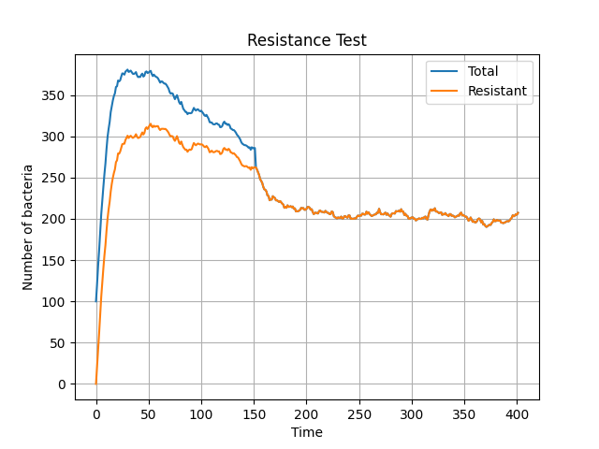

Figure 1. The chronology for Simulation A, where the birth probability is 0.3. (Seed = 0)

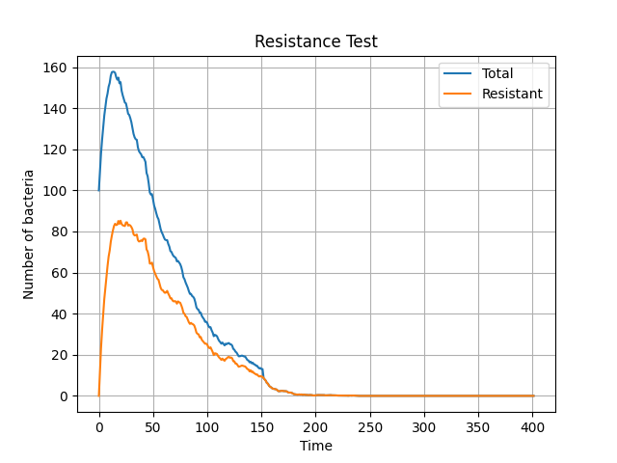

Figure 2. The chronology for Simulation B, where the birth probability is 0.17. (Seed = 0)